Test -1
Python Programming
Section -2 Max Marks – 15
Time – 50 minutes

- Illustrate the different types of control flow statements available in Python with flowcharts. (Marks - 5)
- Write a Program to Prompt for a Score between 0.0 and 1.0. If the Score is out of range, print an error. If the score is between 0.0 and 1.0, print a grade using the following table. (Marks - 5)
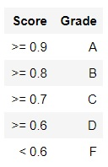
- Write a program to print the sum of the following series 1 + 1/2 + 1/3 +. …. + 1/n (Marks - 5)

